Configuration Details Document – CardioTriage-AI

# 1. Power Platform

### 1.1 Deployment

This document outlines the design, configuration, and implementation of the CardioTriage AI, an AI-powered triage system aimed at automating the patient prioritization process within cardiology departments. The goal of this solution is to improve patient outcomes by ensuring that critical cases are handled promptly and efficiently.

1. Access PowerApps Portal

* Go to [**make.powerapps.com**](https://make.powerapps.com/).
* Sign in using your credentials.

1. Navigate to Solutions

* From the **left menu**, select **Solutions**.
* Click **Import solution** at the top.

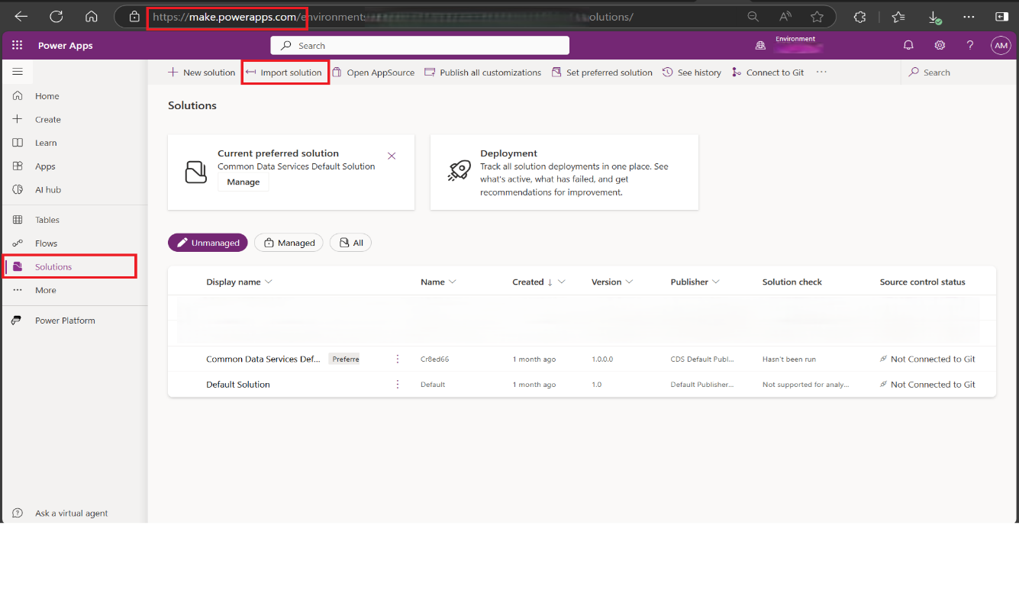

1. Upload the Solution File

* Click **Browse** and select the **.zip** solution file from your local machine.
* Click **Next** to proceed.

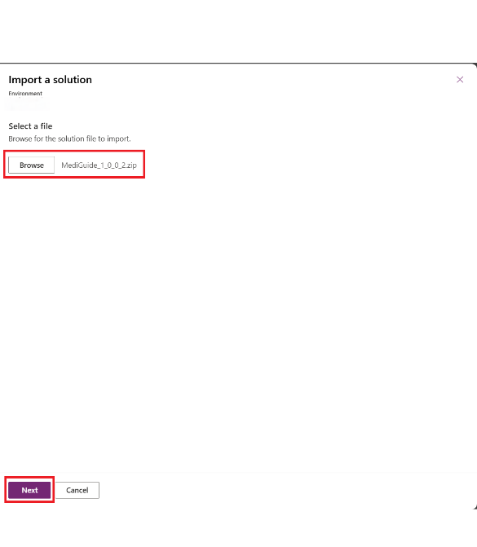

1. Review Solution Details

* Review the solution name and publisher details.
* Ensure that all connections are available/authenticated in the target environment.
* Click **Next** to proceed.

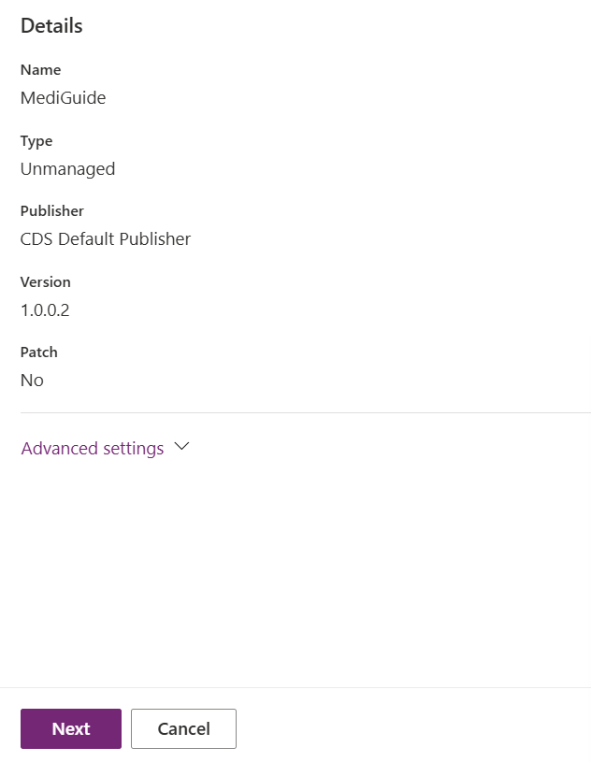 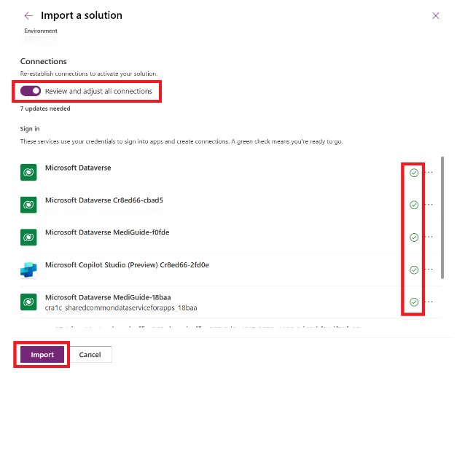

1. Import the Solution

* Click **Import** to start the deployment.
* Wait for the import process to complete. This may take a few minutes.

1. Verify the Deployment

* Once the import is complete, check for any errors or warnings.
* Click on the imported solution to verify that all components (Apps, Flows, Tables, etc.) are present.

### 1.2 Data Set-Up

Please follow the below steps after completion of Section: 2 for configuring the master data related to the settings data  
Step 1: Update ConfigurationData table row in dataverse

1. **Calendar URL**: Newly Created Booking Page URL

2. **ServiceID**: Run the below HTTP query post getting the access token [ Section 2.2] using below query  
GET https://graph.microsoft.com/v1.0/solutions/bookingBusinesses/{business_id}/services Authorization: Bearer {access_token}  
 3. **TenantID** : Directory (Tenant) ID

Step 2: Update the Doctors data along with its Reference (StaffMemberIds) in Dataverse

1. Get Business ID (Booking Calendar ID):
   1. Use the following Graph API endpoint to list your Booking businesses:

GET <https://graph.microsoft.com/v1.0/solutions/bookingBusinesses>

* 1. This will return the **id** of the Booking business (calendar), which you'll need for the next step.

1. Retrieve Staff Members:
   1. Once you have the **business ID**, use it to get the list of staff members:

GET <https://graph.microsoft.com/v1.0/solutions/bookingBusinesses/{business-id}/staffMembers>

* 1. Replace {business-id} with the actual ID retrieved in Step 1.

1. Extract Staff Member ID:
   1. The API response will contain details about each staff member, including their ID.

# 2. Microsoft Bookings

### 2.1 Booking Page

Please find the steps to configure the Booking Page below :  
  
Step 1: Enable Microsoft Bookings

1. Ensure that Microsoft Bookings is enabled in Microsoft 365 Admin Center → Settings → Org Settings → Bookings **[Global Administrator]**
2. Required licensed access (Microsoft 365 Business Premium, E3/E5, A3/A5).

Step 2: Create a Shared Booking Page

1. Open Microsoft Bookings.

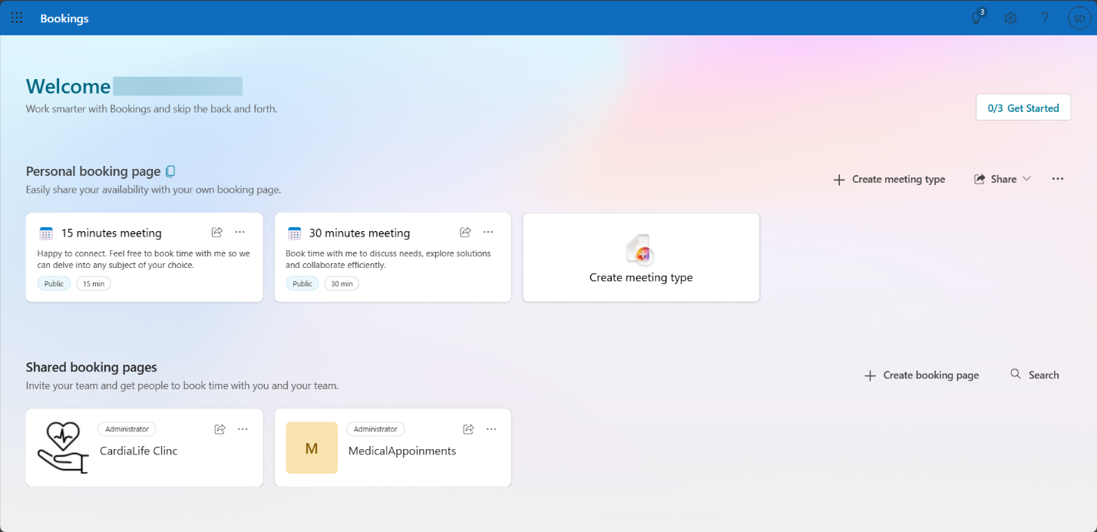

1. Click **Create a Booking Page**.

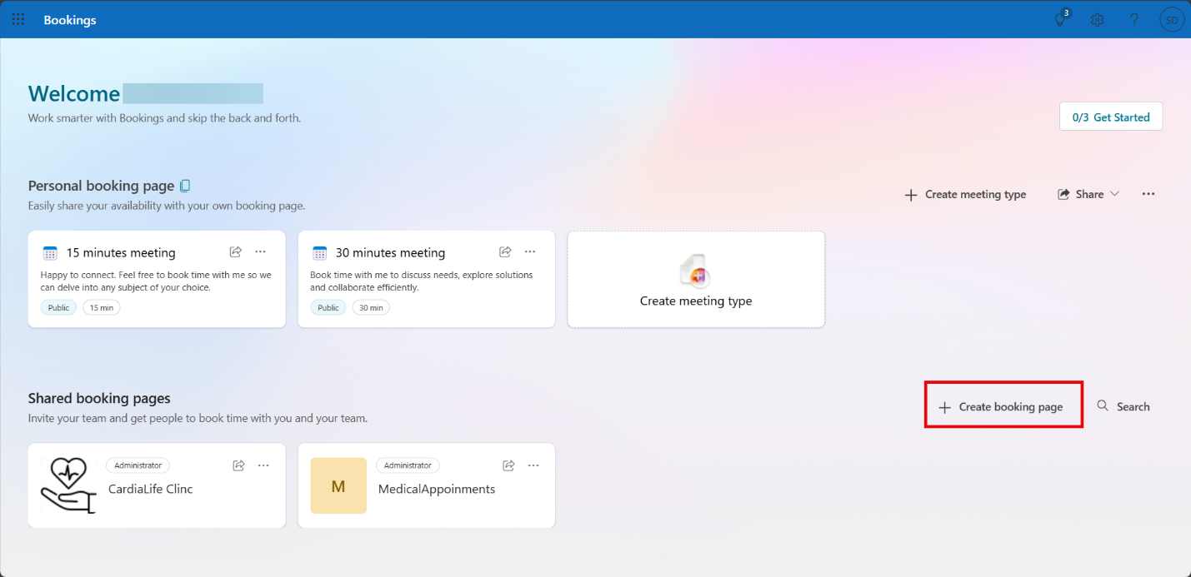

1. Enter **Clinic Name, Address, Phone, Email, Business Hours**.

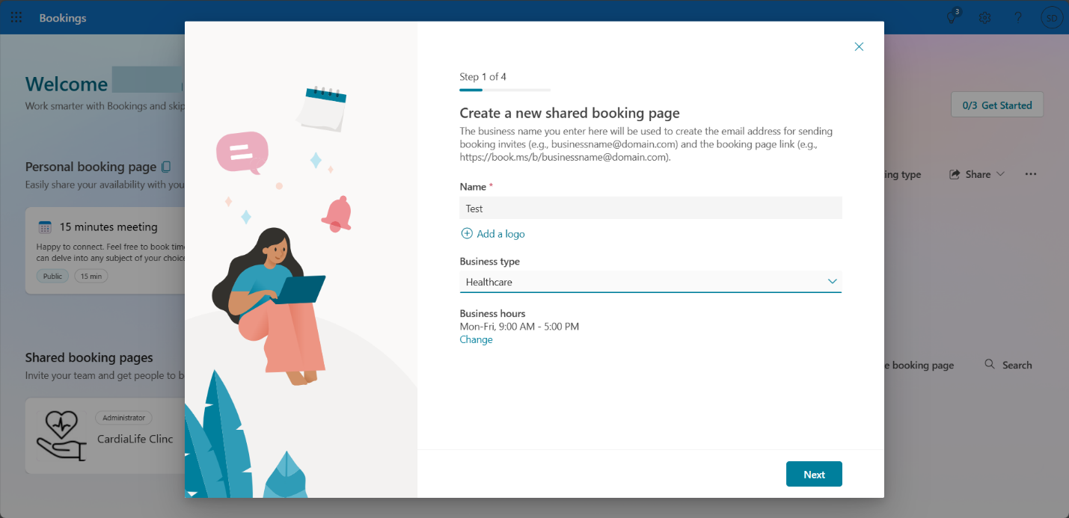

Step 3: Add Staff & Set Availability

1. Click **Staff** → **Add Staff** (Doctors & Admins).

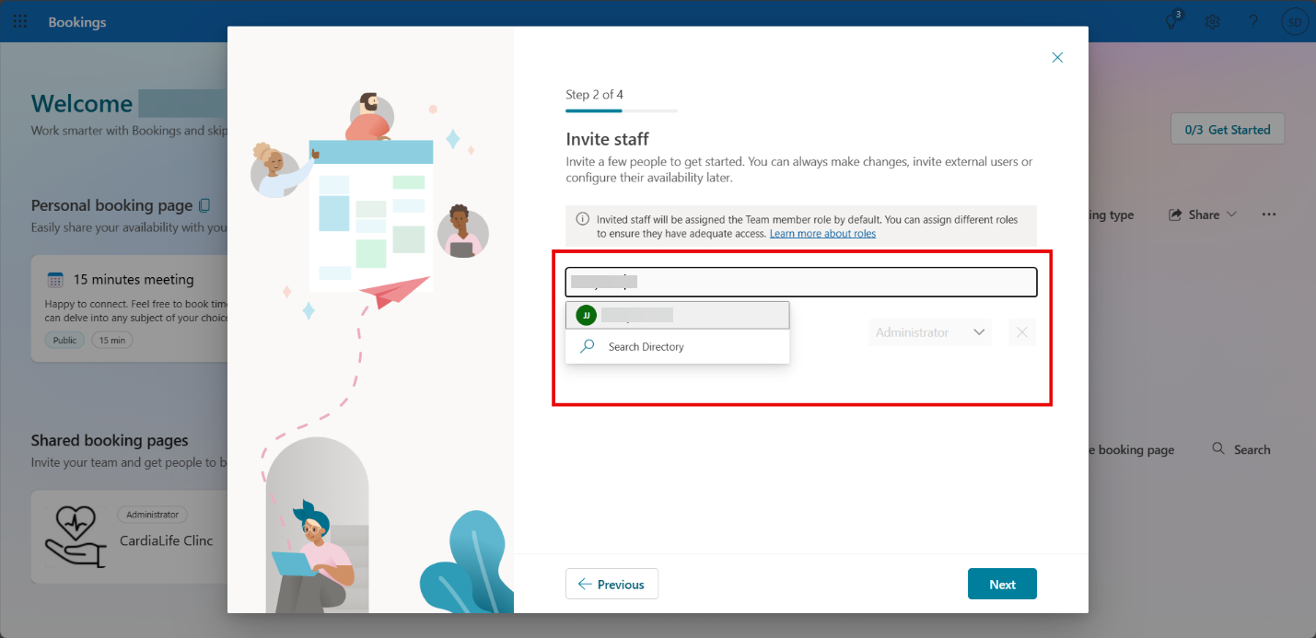

1. Assign roles (**Administrator, Viewer, Guest**).

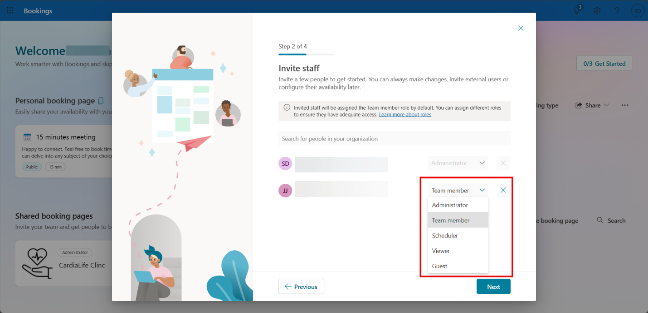

1. Set **working hours** and **availability** for each doctor.

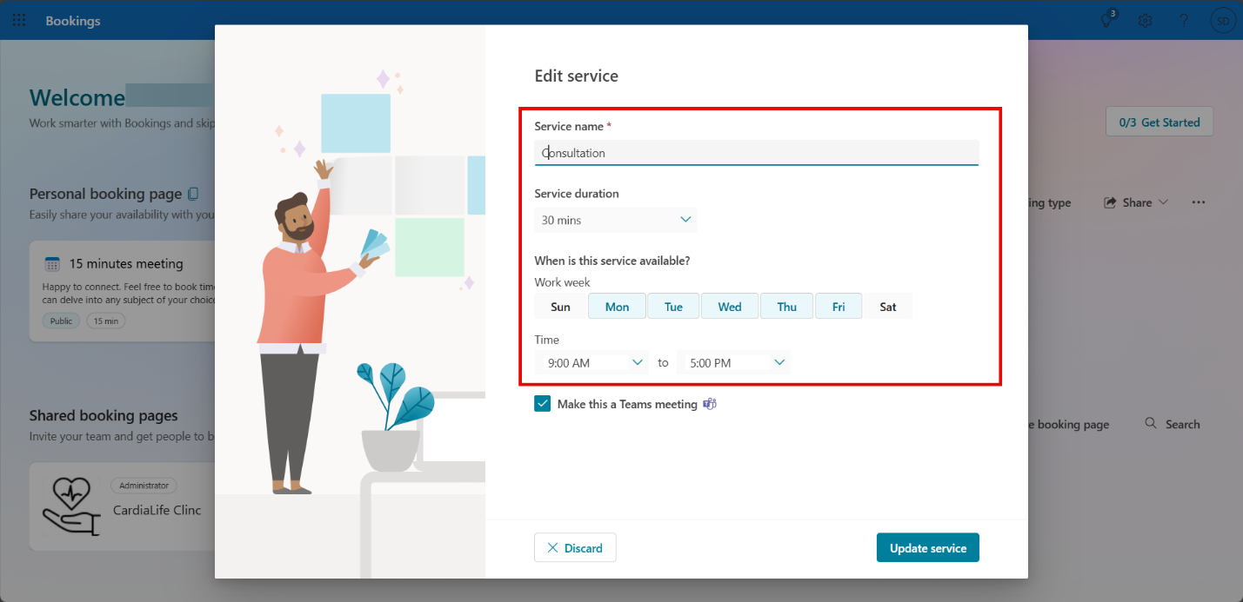

1. Click on Create

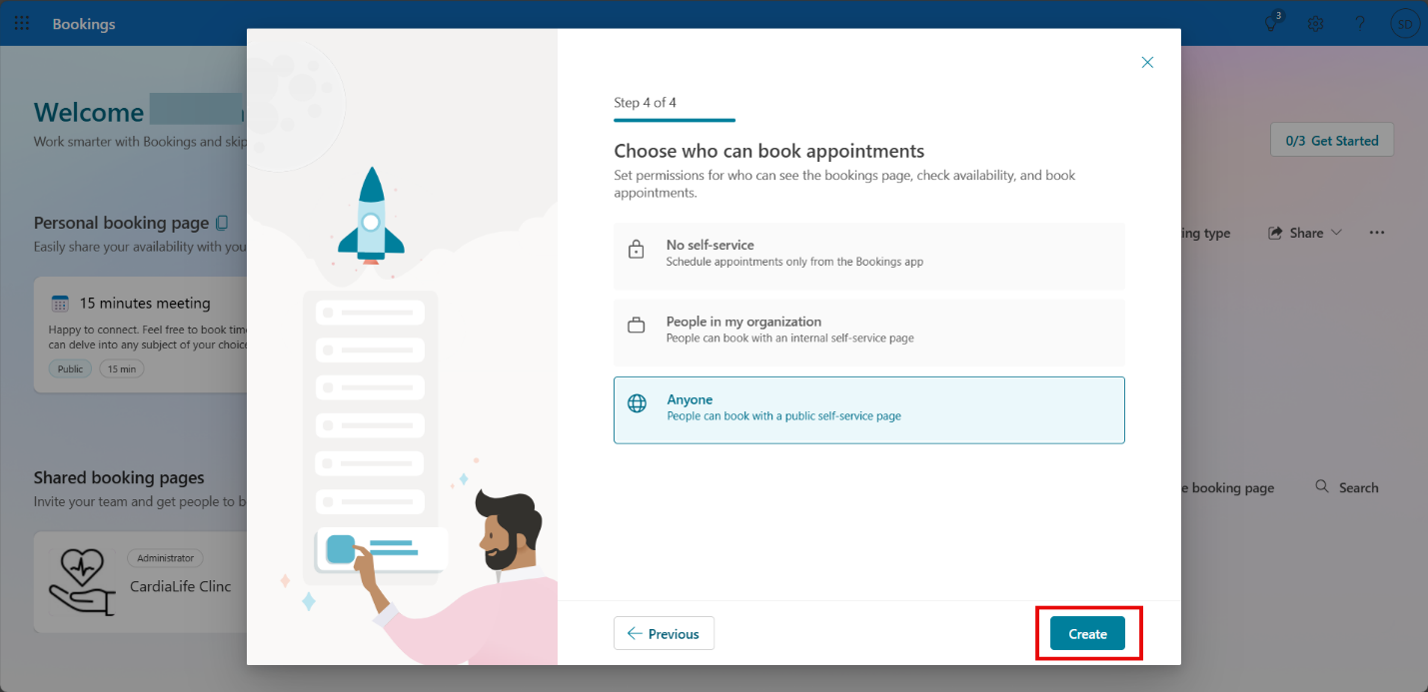

Step 4: Publish & Share the Booking Page

1. Set the **Booking Page to Public** or **Restrict to Microsoft 365 users**.

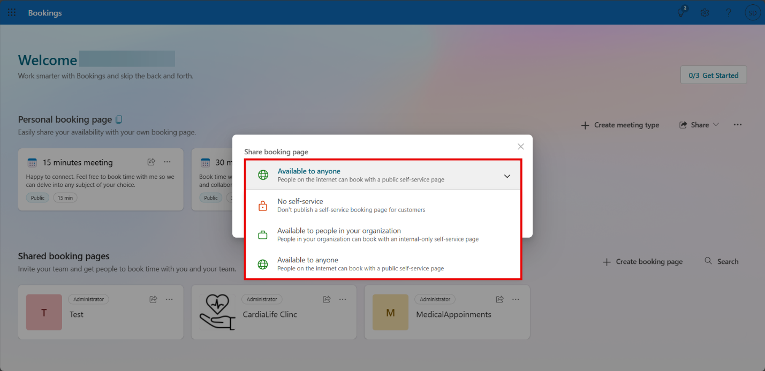

1. Share the **Booking Link** via website, email, or social media.

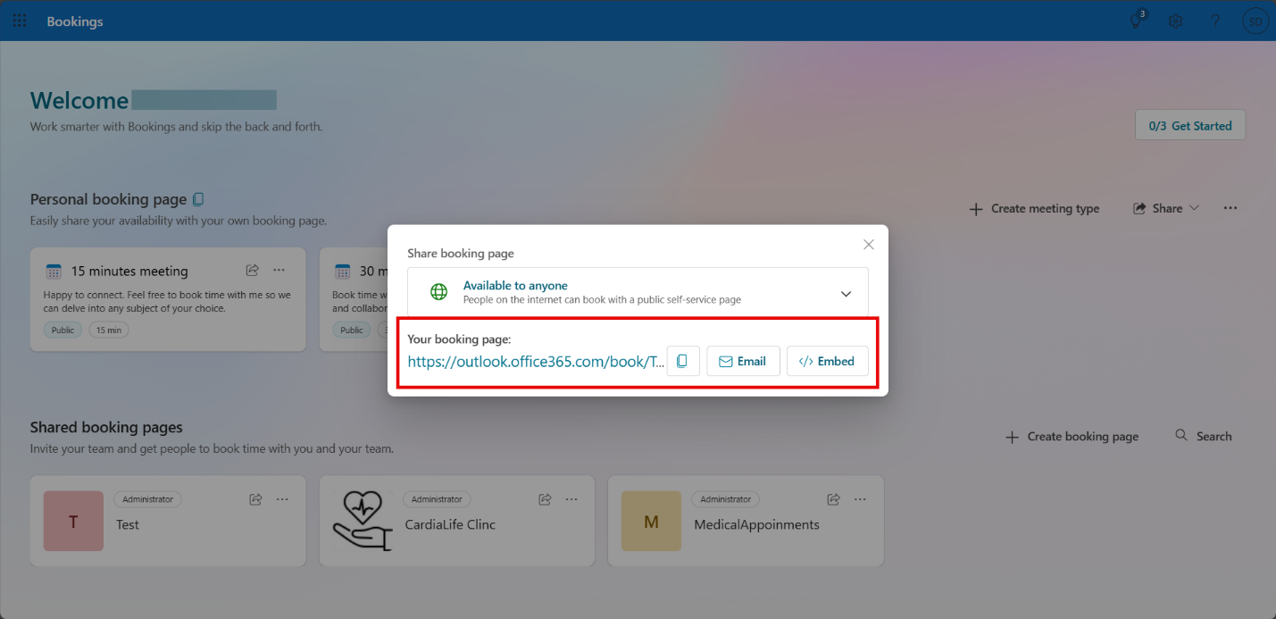

Step 5: Test & Verify

1. Perform a **test booking**.
2. Ensure **appointments sync correctly** and notifications work.

### 2.2 Enabling App Registration with Microsoft Graphs for Microsoft Bookings

easier for patients to book appointments and for staff to manage their schedules. It helps optimize resources by providing an easy-to-use interface for managing appointments. In a technical solution, Microsoft Bookings would simplify appointment management, allowing patients to schedule visits and staff to organize their time without any hassle. If you need to integrate Microsoft Bookings with Microsoft Graph, here’s a straightforward guide to get you started.

1. Go to Azure AD and Register an App
   1. Open the [Azure Portal](https://portal.azure.com/) and go to **Azure Active Directory** → **App registrations**.
   2. Click **+ New registration** and give your app a name (e.g., "Bookings Integration").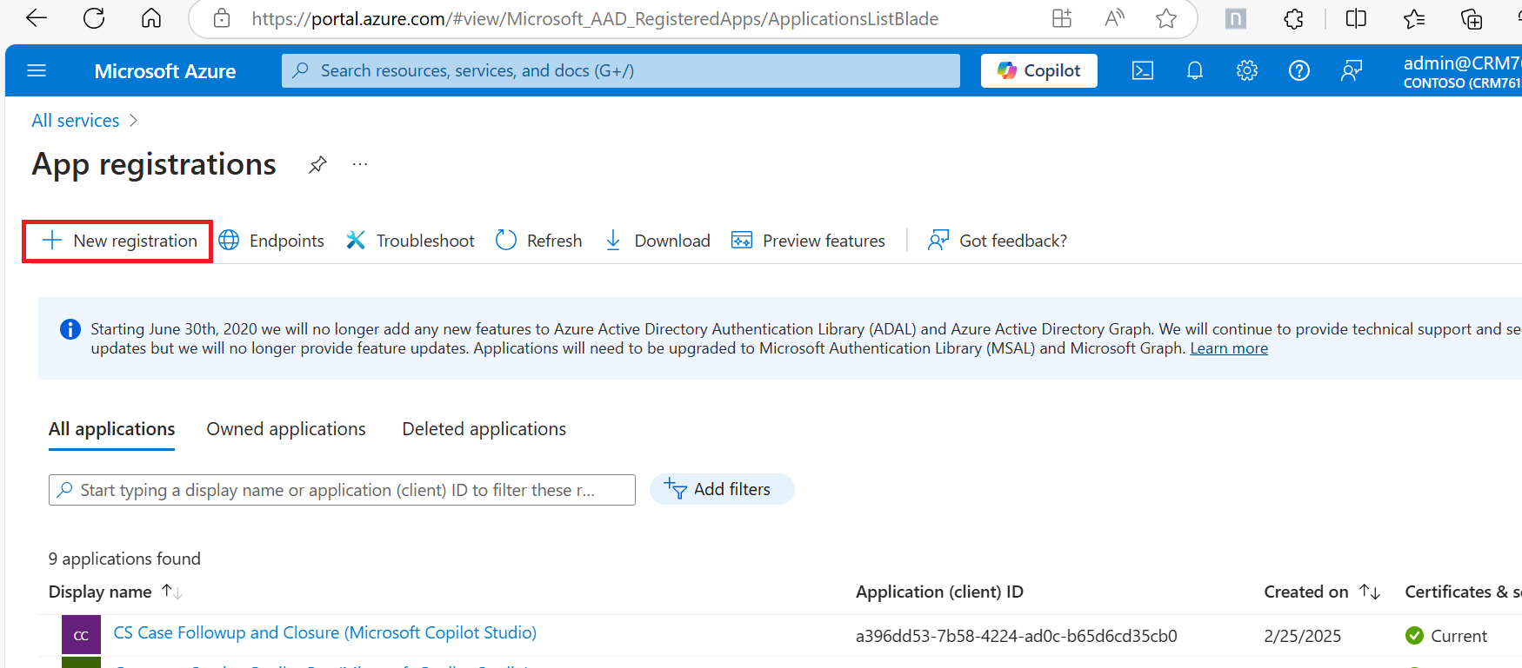
   3. Choose who can access the app (**Single Tenant** is recommended unless you need multi-org access).
   4. (Optional) Add a **Redirect URI** if needed for authentication.
   5. Click **Register** to create the app.

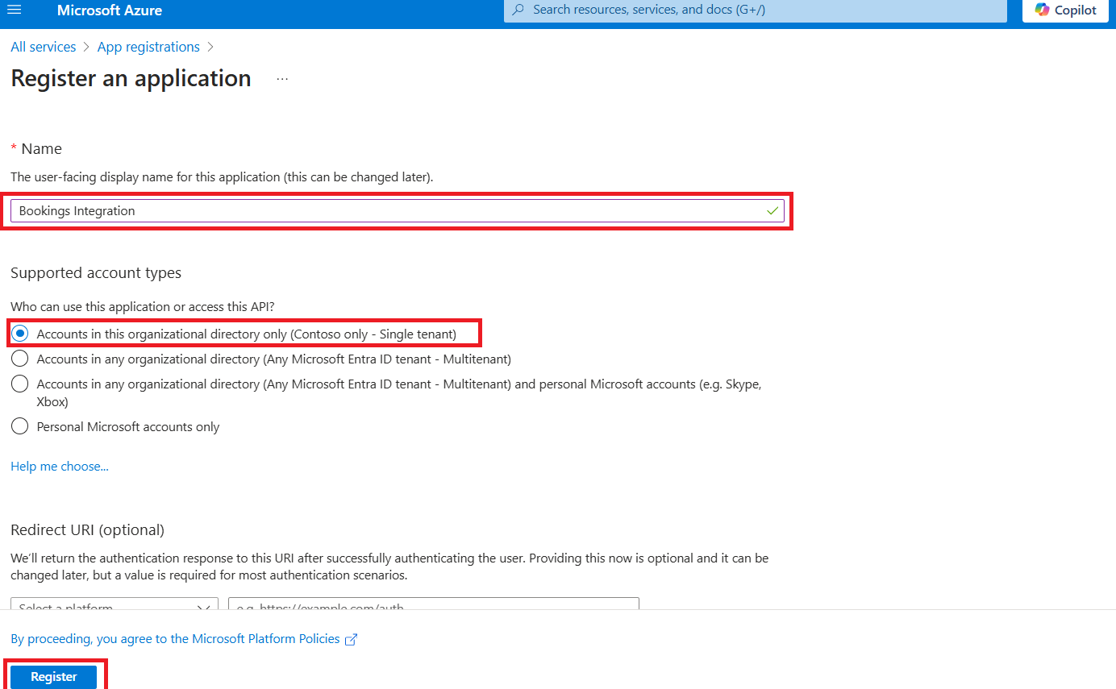

1. Set Up API Permissions
   1. After registering, go to **API Permissions** → **+ Add a permission**.  
        
      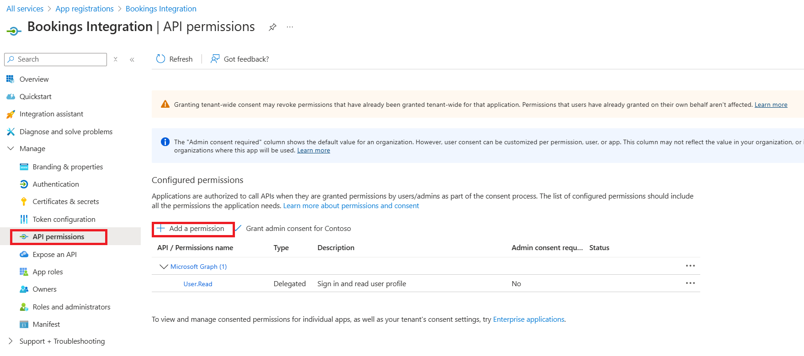
   2. Choose **Microsoft Graph** → **Application permissions.**

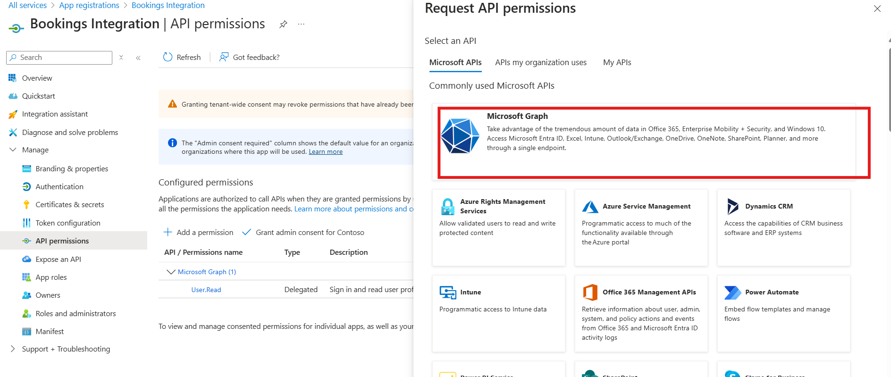

* 1. Search for and add these permissions:
     1. Bookings.Read.All (Read bookings)
     2. Bookings.Manage.All (Full control over bookings)
     3. BookingsAppointment.ReadWrite.All (Manage appointments)
     4. BookingsStaff.ReadWrite.All (Manage staff info)

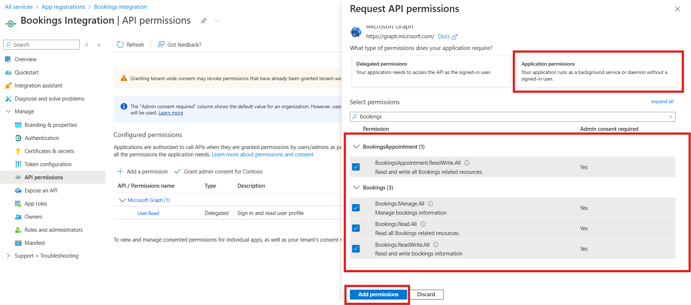

* 1. Click **Add permissions**, then click **Grant admin consent** so your app can use them.

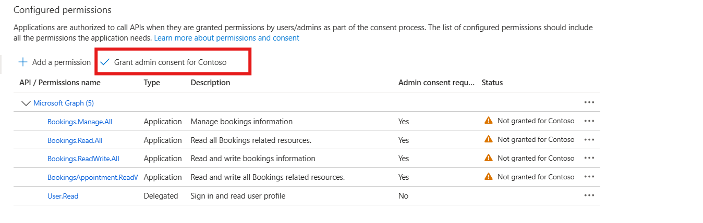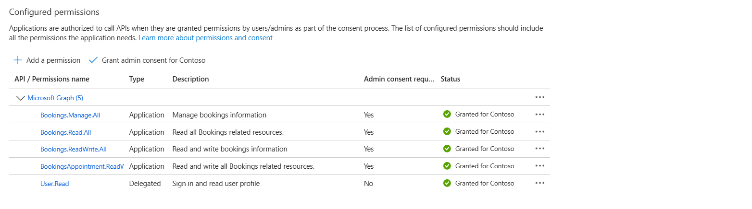

1. Create a Client Secret
   1. Go to **Certificates & secrets**.
   2. Click **+ New client secret**, set an expiration time (e.g., 6 months or 1 year), then click **Add**.  
      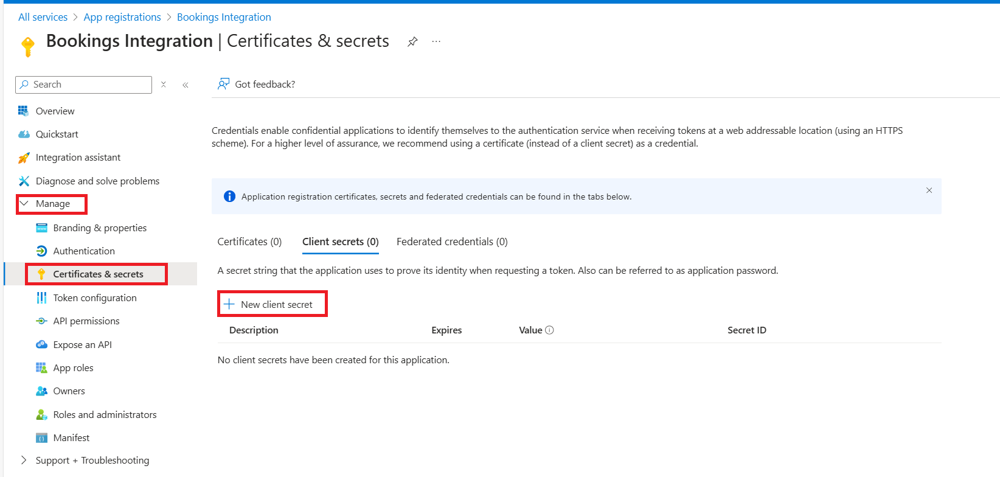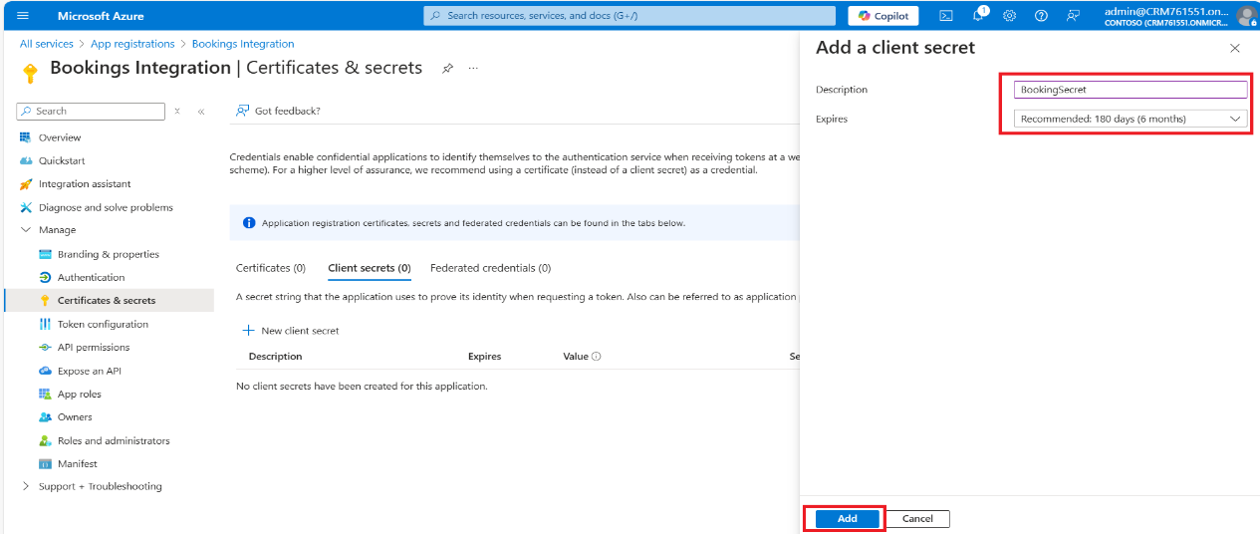
   3. Copy and **save the secret value immediately**—you won’t be able to see it again later.  
      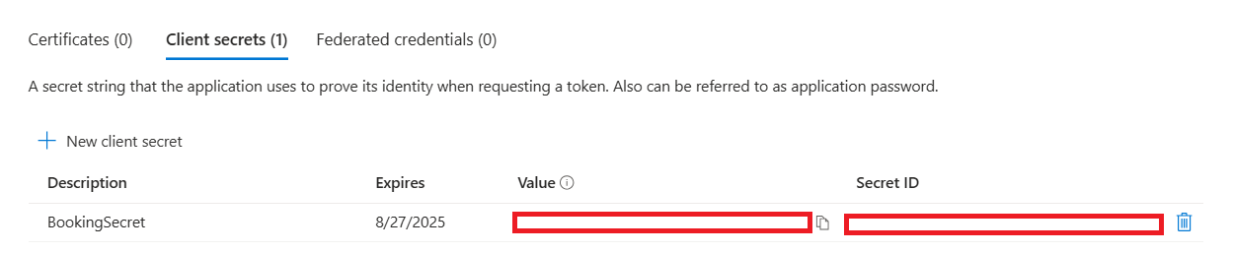
2. Get Your App Details
   1. Under **Overview**, copy these key details:
      1. **Application (Client) ID**
      2. **Directory (Tenant) ID**
      3. **Client Secret** (from Step 3)

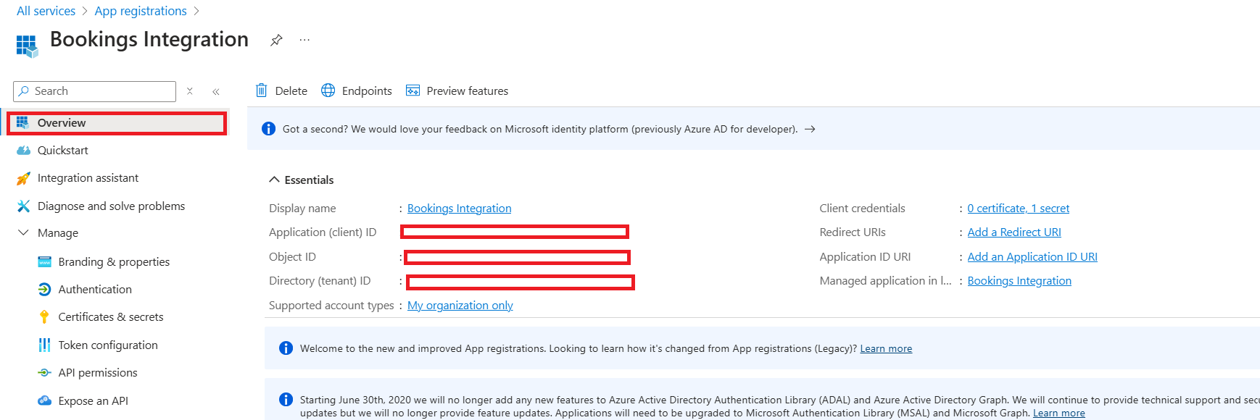

1. Start Using Microsoft Graph with Bookings
   1. Now you can authenticate using OAuth 2.0 and call Microsoft Graph APIs.